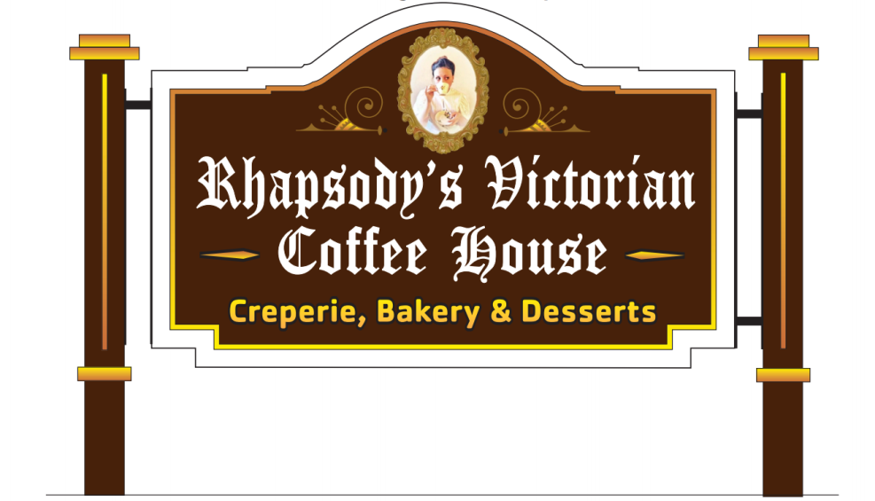
Let your voice be heard!
Are you a woman veteran who wants to have your voice heard?

If so, stop by Rhapsody’s Victorian Coffee House; 395 East Central Street, Franklin, MA 02038 on Saturday, February 24, 2018 between 10:00AM and 2:00PM

Veterans Service Officers from the 4th Congressional District will be in attendance:
Estelle Flett, Norton; Micaila Britto, Raynham; and Dale Kurtz, Franklin will be there to field your concerns.

